Experiment 2a): Scheduling of Project with PERT

Aim
To schedule a project using PERT techniques in ProjectLibre and estimate the project completion time.
Procedure
- Create a new project in ProjectLibre.
- Enter project activities with Optimistic (O), Most Likely (M), and Pessimistic (P) time estimates.
- Calculate the expected time for each activity.
- Develop the PERT network using activity dependencies.
- Determine the Critical Path and total project completion time.
- Save the project.
Result
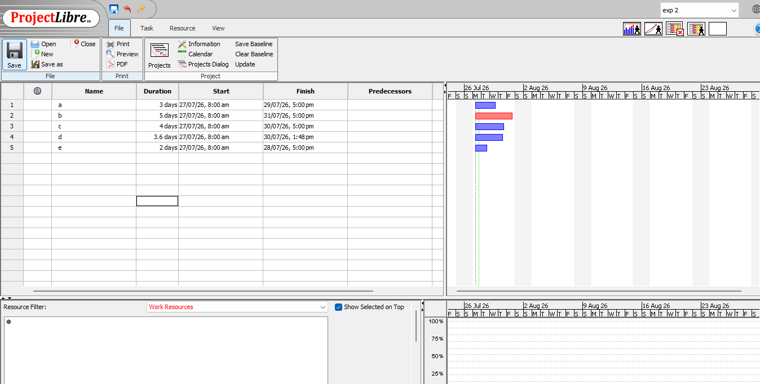

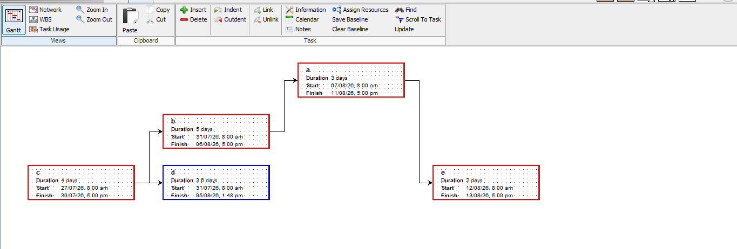

Experiment 2: Scheduling of Project CPM

Aim
To schedule a project using CPM techniques in ProjectLibre and estimate the project completion time.

Procedure
- Open ProjectLibre and create a new project.
- Enter project activities and their durations.
- Set predecessor relationships between activities.
- Generate the Gantt Chart and Network Diagram.
- Identify the Critical Path and estimate the project completion time.
- Save the project.
Result
